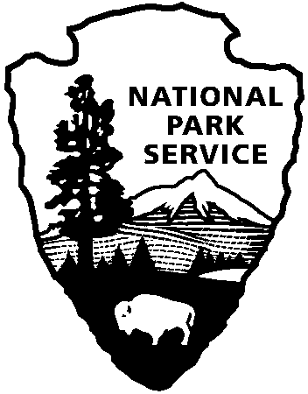
Grand Canyon National Park

PO Box 129
Grand Canyon, AZ 86023

www.nps.gov/grca
National Park Service
U.S. Department of the Interior

Grand Canyon National Park 2017 Earth Day Information Sheet

Please fill out the information below in a clear and concise manner. If possible, fill out electronically and return the form via email to Green Team member Kim Park at kim_park@nps.gov. Otherwise, fill out and return the form via mail to Kim Park at P.O. Box 129, Grand Canyon, AZ 86023. All forms must be received by Friday, March 17, 2017 to be considered for participation in the park’s open-house style Earth Day celebration Saturday, April 22, 2017.

- Name of organization or business

- How many people from your organization or business would like to participate? Do you need tables and chairs, if so how many? (Please, do not bring tent structures)

- How does your organization or business work to benefit the Earth in protecting natural resources or promoting waste reduction?

- Why do you think your organization or business would fit well with Grand Canyon’s 2017 Earth Day celebration?

